# Exercise: Introduction to HTML and CSS

## Welcome to HTML

Create a Web Page like the following.

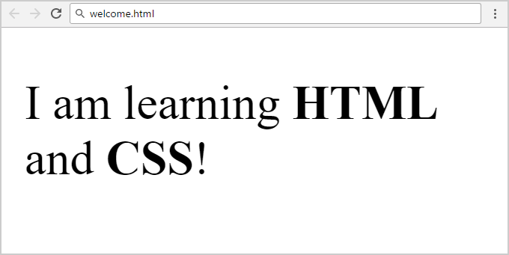

Create "**welcome.html**" document.

### Constraints

* Change the title
* Use paragraph tag for plain text and strong tag for bold text

## Lists

Create a Web Page like the following.

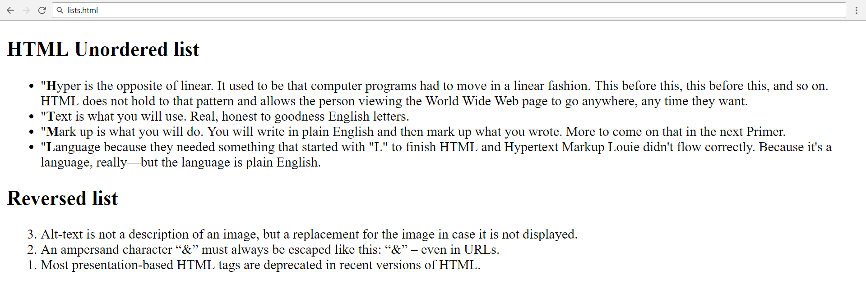

### Constraints

* Change the title
* Use <ul> for unordered list
* Use <ol> for ordered list

## Nested Lists

Create a Web Page like the following.

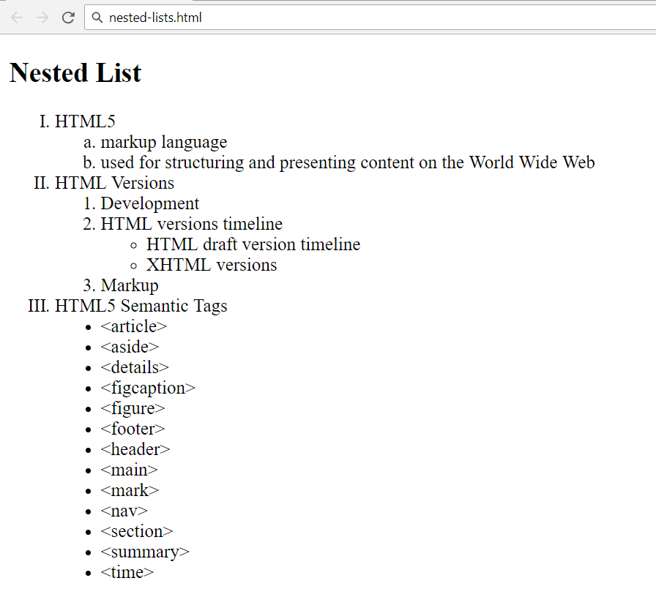

### Constraints

* Change the title
* Use different types for ordered and unordered lists

## Simple Data Table

Create a Web Page like the following.

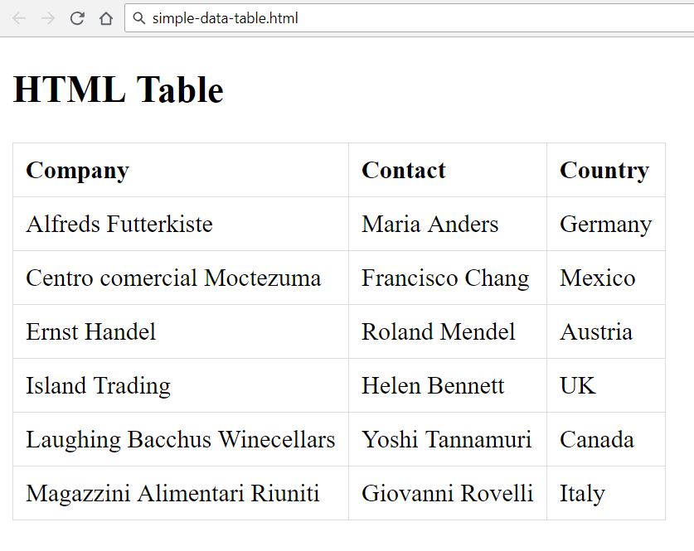

### Constraints

* Change the title
* Add the following CSS to your head in <style>

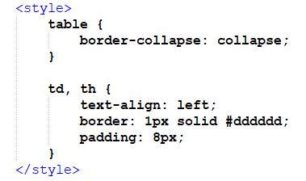

## Checkout Table

Create a Web Page like the following.

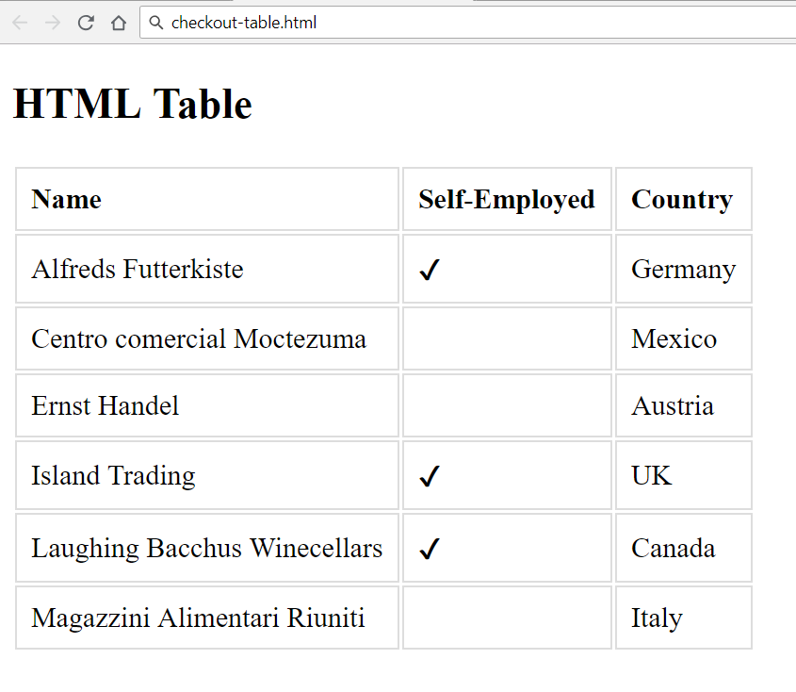

### Constraints

* Change the title
* Add the following CSS to your head in <style>

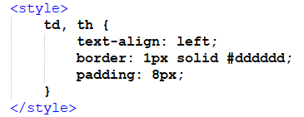

* Use HTML Entities for the tick